1. MyAccount section customization on SuiteCommerce, mirror inventory items on webstore:
Section on my account with “MyDownloads” name: to show all the downloads that the customer has purchased,
Create up to one (1) page view on the MyAccount section to list Downloadable Items purchased by the user where we’ll list Date, Item number, Description and Link.

new section on MyAccount displaying the results of a Saved Search listing all purchased Downloadable Items. Usamos una saved search, de ellos?
Assist them on the build of the Saved Search

List cada item, y poner para descargar
(40hs)
We can not do downloadable items.

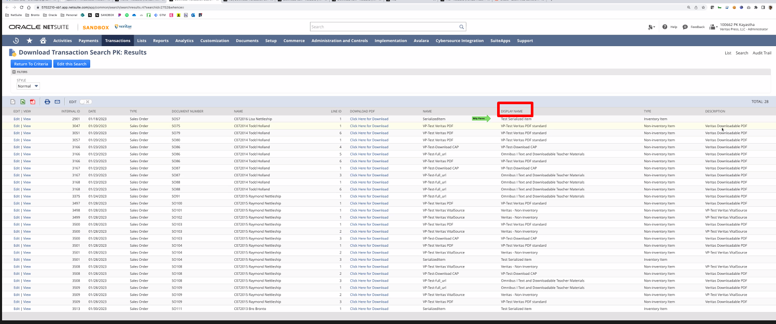

Display name is decription
Name is item name
Date
And link there

Assume that the file name is always the same as the displayname
Folder would be always the same

Solo va amostrar description, pero no viene site description and caption.

Just do a load file
Assume that:
- the name of the file would be the same as the downloadable item name
- It will only be one item per downloadable item

Questions to ask:

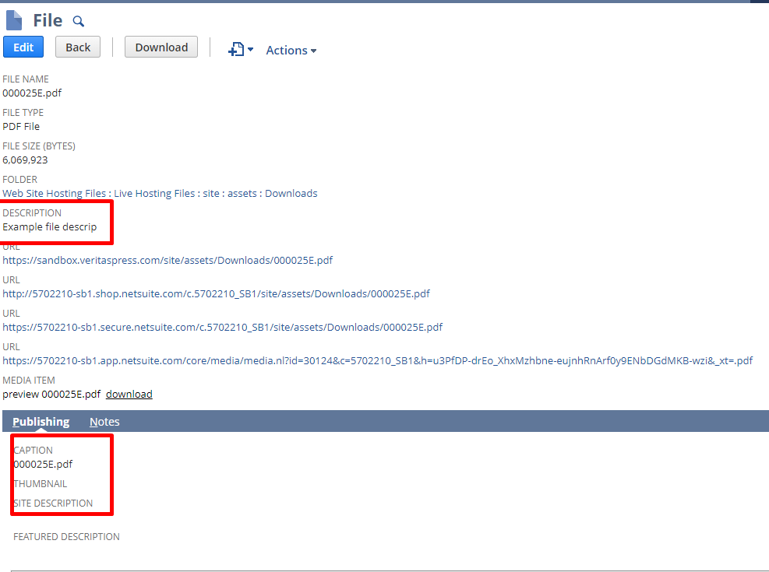
- Caption and site description are not stated on SOW and we can not load them through load record, not possible to do.

- Is this really needed this description file? This will add a lot of complication/overhead to add, will lead to more hours of development.

Are you guys going to use saved search? Or going to use this section on netsuite that you guys showed?

- Paso menú addMenuGroup
- Page type para escuchar la url, anda al page type que dibuje la sc view que voy
- Page Type Base View

Aplicar estilos de netsuite para la tabla, copiar rows y columns, y fijarse clases que usa arriba.

